**Quantitative Random Variables**

1. **Discrete Random Variable**

A random variable X is a **discrete** RV if either the range of X is finite or the range is an infinite sequence of values. For a discrete RV the probability characterization is the function p(x) = P(X = x) which is defined for every value x of X. The function p(x) is sometimes given as a formula and sometimes as a table of values. Given the probability function p(x), we can calculate the probability of any collection of values for X by adding the probabilities for all of the these values.

**Example 1** Toss a fair coin 5 times. Let X = number of heads produced

Values of X

The probability function p(x)

What is the probability that an even number of heads is produced?

What is the probability that at least 2 heads are produced?

This example is an instance of an important kind of discrete RV : **BINOMIAL DISTRBUTION**

Binomial Coefficients: $\left(\begin{aligned}n \\ k\end{aligned}\right)$ = $\frac{n!}{\begin{aligned}k!\left(n-k\right)! \\ \end{aligned}}$

Suppose we toss a coin n times and the probability of getting a head on a single toss is p. Let X be the number of heads produced on the n tosses. Then,

P(X = k) = $\left(\begin{aligned}n \\ k\end{aligned}\right)$ pk(1-p)n-k, k = 0,1, …,n

**Example 2** Two cards are dealt from an ordinary deck of playing cards. Let X = number of aces dealt.

Values of X

The probability function p(x)

What is the probability of getting at least one ace?

**Example 3** A fair coin is tossed until a head is produced. Let X = number of tosses to produce the first head.

Values of X

The probability function p(x)

A useful result from infinite series:

What is the probability that it takes at least 4 tosses to produce the first head?

What is the probability it takes an even number of tosses to production first head?

2. **Continuous Random Variable**

A **continuous** RV is a random variable whose range is an interval of real numbers.

Randomly select an adult male: Let X = (exact) height in inches

Randomly select a washer produced by a particular machine. Let X = (exact) diameter in mm.

For a continuous RV X, if x is in the range of X, P(X = x) = 0, so characterizing the probability of X by the function p(x) = P(X = x ) doesn’t work. Instead, the probability characterization is its probability density function, f(x).

**Density Curves and Density Functions**

**Density histograms**

**Example**

* histogram(~height,data= Galton)

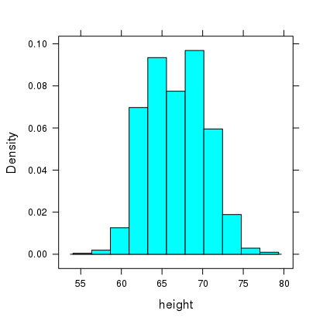

What is the significance of the density scale? The area of each rectangle gives the percent (proportion) of the observations in the corresponding range.

* densityplot(~height,data= Galton)
* 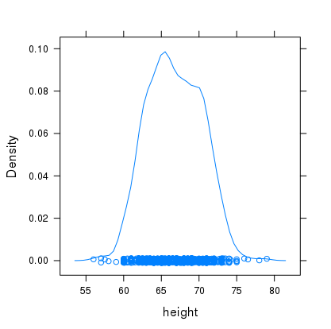

The density curve has the property that for any interval on the x-axis, the area below the density curve gives (approximately) the percent (proportion) of the data whose values are in that interval.

**The Probability Density Function (pdf) for a Continuous Random Variable**

Let X be a continuous random variable. The function f(x) is the **probability density function** for X if, for any set A of real numbers,

.

I.e., the probability of an event A is the area below the density curve above the event A.

We calculate the probability of an event A by integrating the density function over the event A.

**Basic Properties of a Density Function**

a.

b.

**A Simple Example** Let X be a number randomly chosen from the interval [0,2]. The range of X is [0,2]. Since the X is selected randomly, no value of X is more likely to be selected than any other value, so the density function f(x) is constant on [0,2]. What is the constant value?

P(0 ≤ X ≤ 1) P(1 ≤ X ≤ 3/2) P(1 ≤ X ≤ 3)

A random variable X whose density function is constant (where it is non-zero) is said to have a **uniform distribution**.

**Example**: Let f(x) 

Verify that f(x) is a probability density function

Compute P(1 ≤ X ≤ 3/2) Compute P(1 ≤ X ≤ 4)

The **Cumulative Distribution Function** (cdf) for a Random Variable X

F(x) = P(X ≤ x)

**Example**  Let X have a uniform distribution on [0,4]

pdf f(x) =

cdf F(x) =

**Example**  Let X be the random variable whose pdf is f(x) .

Find the cdf for X.

**Using cdf to compute probabilities**

If F(x) is the cdf for the random variable X, then P(a ≤ X ≤ b) = F(b) – F(a).

**Example**: Let F(x) .

P(X ≥ ½)

P(1/2 ≤ X ≤ ¾)

P(-2 ≤ X ≤ 1/2)

**Using the cdf to compute the pdf**

If f(x) is the pdf and F(x) is the cdf, then f(x) = F’(x).

Find the pdf for the cdf in the example above.

**Example** The function f(x) is a probability density function.

If X is the corresponding random variable, find P(X > 2) using the pdf.

Find the cdf for X and use the cdf to find P(X < 1)

**Exercises 5**

1. Parts coming off an assembly line have a 1% chance of being defective. If 3 parts are randomly chosen from this line and X is the number of defective parts.
2. Compute the probability function p(x) for X.
3. What is the probability that at least one of the three is defective?
4. Parts coming off an assembly line have a 1% chance of being defective. All of the parts coming off the line are inspected. Let X be the number of the first defective part found.
5. Find the probability function p(x) for X.
6. What is the probability that the first defective part is the 100th part?
7. A biased coin has a 40% chance of producing a head. If it is tossed 10 times,
8. What is the probability of getting exactly 3 heads?
9. What is the probability of getting 3 or more heads. (This can be calculated in two different ways. The easier way uses the complement rule.)
10. a. Find the value of C for which the function f(x) is a probability density function.

b. Use your density function in (a) to find P(0 ≤ X ≤ 1) and P(1 ≤ X ≤ 5).

c. Use your probability density function in (a) to compute the cumulative distribution function F(x).

5. a. Find the value of C for which the function f(x)  is a pdf.

b. Find P(X ≤ 2).

1. Find P(X > 3)
2. Find the cumulative distribution function F(x).
3. Use the cumulative distribution function to find P(2 ≤ X ≤ 5).